Smart Lender Applicant Credibility

Prediction for Loan Approval

Project Report

Team Members
Jagan Raparthi
Nafia Shaik
Tarun Kumar Swamy Sappa
Hasini Darshe
Bekkam Siva Rama Krishna
Table of Contents
- INTRODUCTION
  - Project Overview
  - Purpose
- LITERATURE SURVEY
  - References
  - Problem Statement Definition
- IDEATION & PROPOSED SOLUTION
  - Empathy Map Canvas
  - Ideation & Brainstorming
  - Proposed Solution
  - Problem Solution fit
- REQUIREMENT ANALYSIS
  - Functional requirement
  - Non-Functional requirements
- PROJECT DESIGN
  - Data Flow Diagrams
  - Solution & Technical Architecture
- CODING & SOLUTIONING
  - Feature 1
  - Feature 2
Database Schema (if Applicable)
- TESTING
  - Test Cases
  - User Acceptance Testing

- RESULTS
  - Performance Metrics
- ADVANTAGES & DISADVANTAGES
- CONCLUSION
- FUTURE SCOPE
- APPENDIX
  - Source Code

Chapter 1: INTRODUCTION

Project Overview
The credit system governed by the banks is one of the most important factors which affect our country’s economy and financial condition. Also, credit risk is one of the main functions of the banking community. The prediction of credit defaulters is one of the difficult tasks for any bank. This problem occurs when the banks need to provide loans to the customers who are in need of the money. But by forecasting the loan defaulters, the banks definitely may reduce their loss by reducing their non-profit assets.

Purpose
People who need loan and want to check whether they are eligible for loan or not

Chapter 2: LITERATURE SURVEY

References

S. No | Paper | Year | Citation | Methodologies used
1 | Machine Learning Based Model for Prediction of Loan Approval | 2022 | B. P. Lohani, M. Trivedi, R. J. Singh, V. Bibhu, S. Ranjan and  P. K. Kushwaha, "Machine Learning Based Model for Prediction of Loan Approval," 2022 3rd International Conference on Intelligent Engineering and Management (ICIEM) , 2022,  pp. 465-470, doi: | In this paper, they have applied logistic regression as a tool to predict whether an applicant is eligible for the loan or not
10.1109/ICIEM54221.2022.985
3160.
2 | Loan Approval Prediction | 2022 | Shubham Nalawade, Suraj Andhe, Siddhesh Parab, Prof. Amruta Sankhe "Loan Approval Prediction"  ,International Research Journal of Engineering and Technology (IRJET) e-ISSN: 2395-0056 , Volume: 09  Issue: 04 , April 2022 | They have compared the accuracy of different machine learning algorithms. They got a percentage of accuracy ranging from 75-85% but the best accuracy they got was from Logistic Regression i.e.88.70%

3 | Bank Loan Approval Prediction Using Data Science Technique (ML) | 2022 | Subhiksha R, Vaishnavi L, Shalini B, Mr. N. Manikandan,"Bank Loan Approval Prediction Using Data Science Technique (ML)",International Journal for Research in Applied Science & Engineering Technology (IJRASET) ISSN: 2321- 9653, Volume 10 Issue  V May 2022 | In this paper, four algorithms are used such as Random Forest algorithm, Decision Tree algorithm, Naive Bayes algorithm, Logistic Regression algorithm to predict the loan approval of customers. All the four algorithms are going to be used on the same dataset and going to find the algorithm with maximum accuracy to deploy the model.
4 | Algorithm For the Loan Credibility Prediction System | 2019 | Soni P M, Varghese Paul, "Algorithm For the Loan Credibility Prediction System", International Journal of Recent Technology and Engineering (IJRTE)ISSN:2277-3878,  Volume-, Issue-1S4, June 2019 | In this research work a novel hybrid feature selection algorithm using wrapper model and fisher score is introduced. The main objective of this paper is to prove that new hybrid model produces better accuracy than the traditional random forest algorithm

5 | An Approach for Prediction of Loan Approval using Machine Learning Algorithm | 2020 | M. A. Sheikh, A. K. Goel and T. Kumar, "An Approach for Prediction of Loan Approval using Machine Learning Algorithm," 2020 International Conference on Electronics and Sustainable Communication Systems (ICESC) , 2020, pp. 490- 494, doi:  10.1109/ICESC48915.2020.915  5614. | The data is collected from the Kaggle for studying and prediction. Logistic Regression models have been performed and the different measures of performances are computed

Problem Statement Definition
The credit system governed by the banks is one of the most important factors which affect our country’s economy and financial condition. Also, credit risk is one of the main functions of the banking community. The prediction of credit defaulters is one of the difficult tasks for any bank. This problem occurs when the banks need to provide loans to the customers who are in need of the money. But by forecasting the loan defaulters, the banks definitely may reduce their loss by reducing their non-profit assets.

Chapter 3: IDEATION & PROPOSED SOLUTION

Empathy Map Canvas
An empathy map is a simple, easy-to-digest visual that captures knowledge about a user’s behaviours and attitudes. It is a useful tool to help teams better understand their users. Creating an effective solution requires understanding the true problem and the person who is experiencing it. The exercise of creating the map helps participants consider things from the user’s perspective along with his or her goals and challenges.
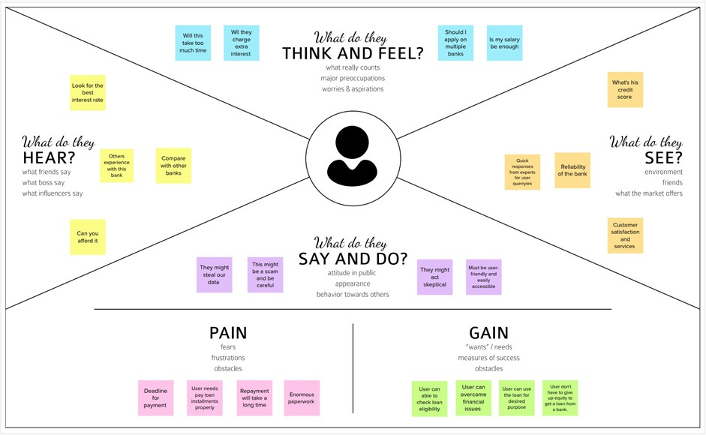

Ideation & Brainstorming
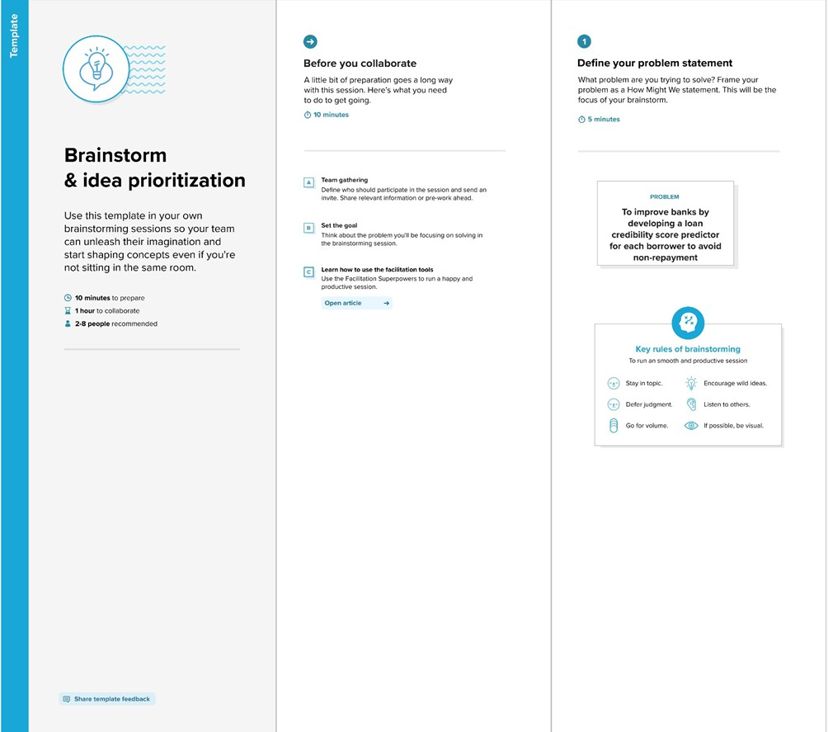

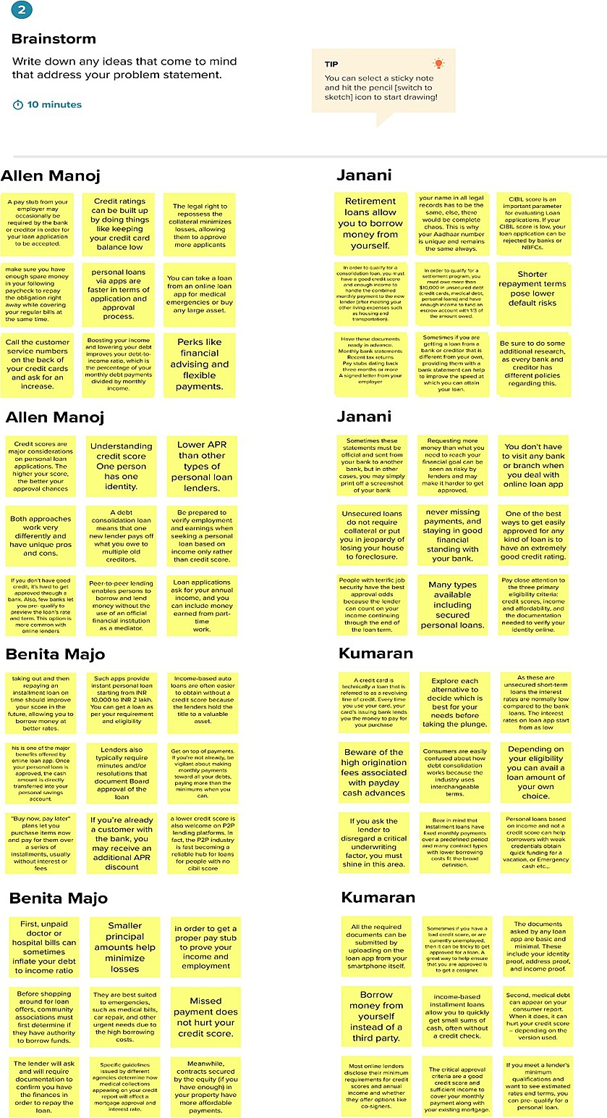

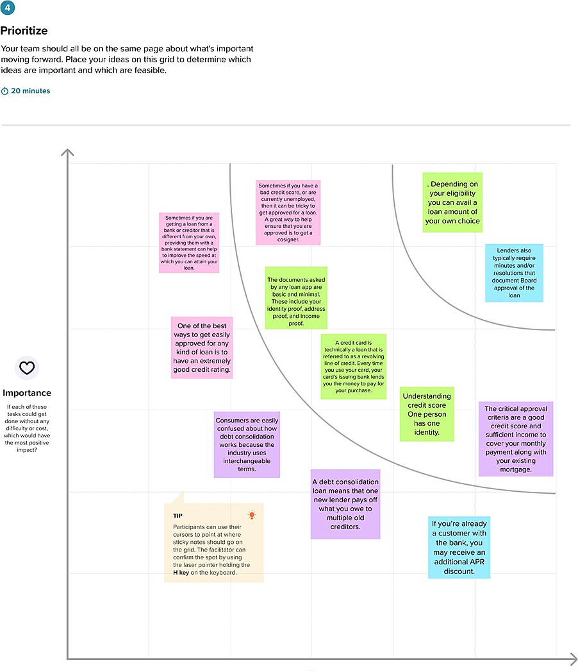

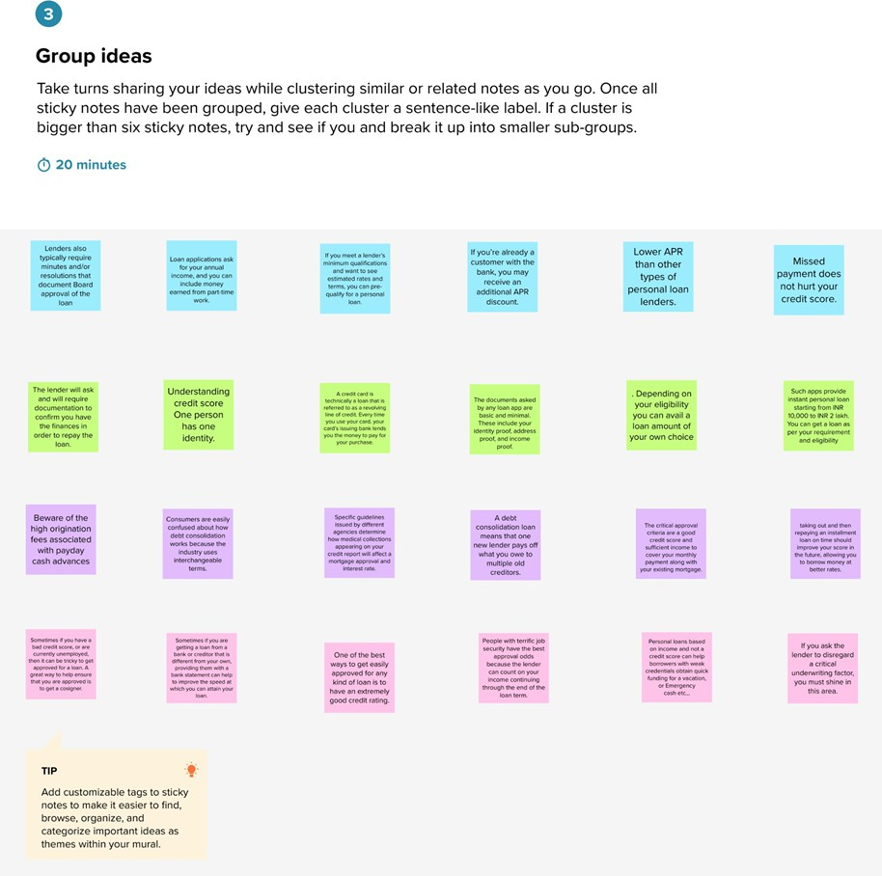
[=

Proposed Solution

S.No. | Parameter | Description
1 | Problem Statement (Problem to be solved) | To accurately predict the credibility of a candidate for loan approval.
2. | Idea / Solution description | Our solution includes developing an ML model that can classify an applicant based on credibility and provide further details regarding the approval of the loan.  Algorithms such as KNN, decision trees, SVM are used
3. | Novelty / Uniqueness | The model will do multiple label classification and provide extra inputs to assist in its determination of whether to approve a loan.
.4. | Social Impact / Customer Satisfaction | The model will carry out multi-label categorization and offer extra inputs to assist the decision to approve the loan.
5. | Business Model (Revenue Model) | Freemium model. Once we reach a particular usage rate, we can monetize features like the ability to see several banks or to apply for numerous banks. We can even provide subscription services.
6. | Scalability of the Solution | Any financial firm may quickly and easily adapt the model. The procedure of classification can be very customizable, but it will be as broad as feasible.

Problem Solution fit
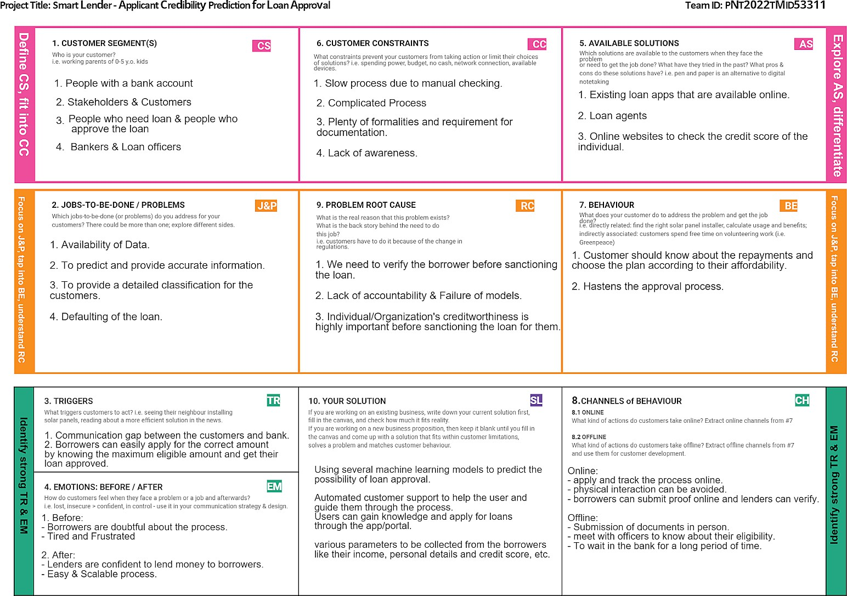

Chapter 4: REQUIREMENT ANALYSIS

Functional requirement

FR No. | Functional Requirement (Epic) | Sub Requirement (Story / Sub-Task)
FR-1 | User Input | - Selecting the type of loan  - Filing the necessary details
FR-2 | Eligibility of Loan | - Loan Approval  - Loan Rejection
FR-3 | Check for approvable amount of loan | - Maximum Eligible loan Prediction
FR-4 | Chatbot | - Clarifying user’s doubts.

Non-Functional requirements

FR No. | Non-Functional Requirement | Description
NFR-1 | Usability | - Easy to use and self-explaining website.  - Easy navigation between pages.  - Simple structure for faster access.
NFR-2 | Reliability | - Ensembling the outputs of various ML  models.
NFR-3 | Performance | - Web Based Application.  - Ability to indicate user inputs of erroneous data types.

NFR-4 | Availability | - Application is available 24 / 7 as it is hosted on IBM  cloud.  - Simple web browser is enough to access the  website.
NFR-5 | Scalability | - Can be extended for other types of loans.  - Aadhar and PAN verification can also be  implemented.

Chapter 5: PROJECT DESIGN

Data Flow Diagrams
A Data Flow Diagram (DFD) is a traditional visual representation of the information flows within a system. A neat and clear DFD can depict the right amount of the system requirement graphically. It shows how data enters and leaves the system, what changes the information, and where data is stored.
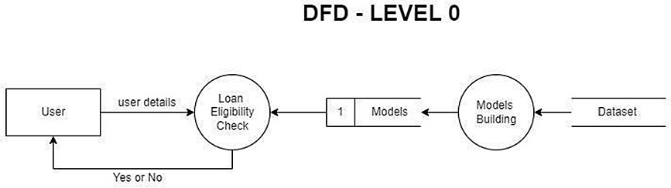

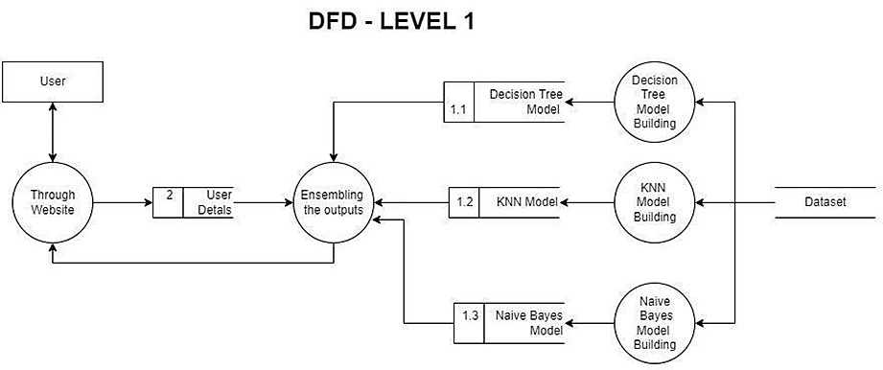

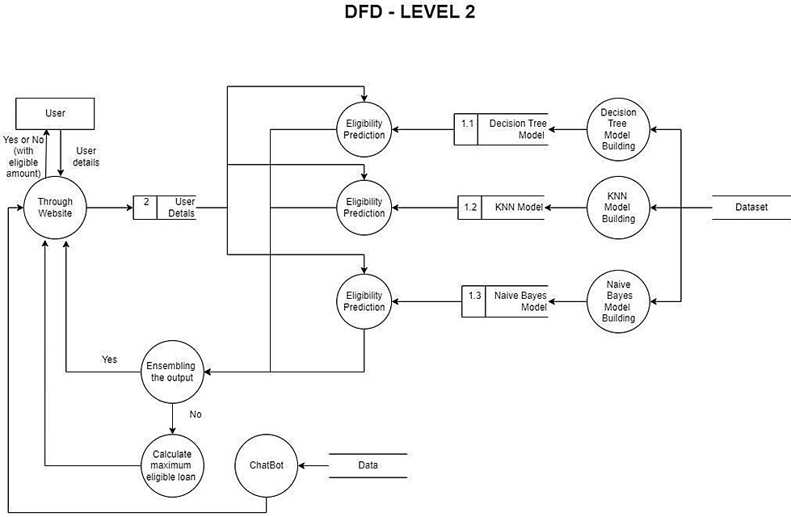

Solution & Technical Architecture Solution Architecture:
Solution architecture is a complex process – with many sub-processes – that bridges the gap between business problems and technology solutions. Its goals are to:
    - Find the best tech solution to solve existing business problems
. ● Describe the structure, characteristics, behavior, and other aspects of the software to project stakeholders
. ● Define features, development phases, and solution requirements

. ● Provide specifications according to which the solution is defined, managed, and delivered.

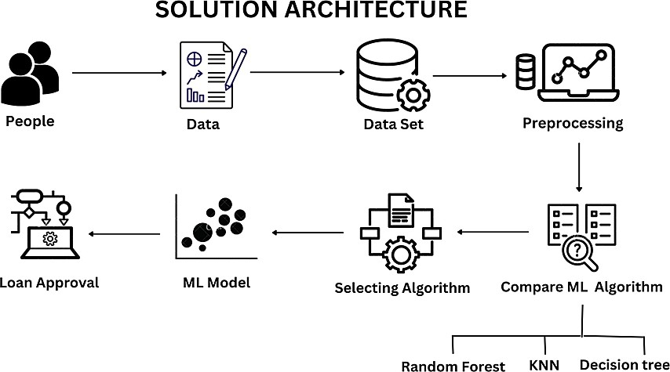

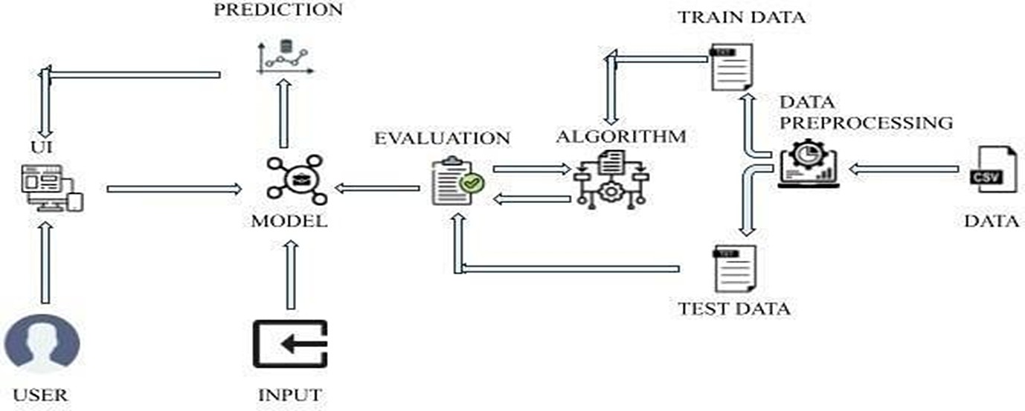
Technical Architectur

Chapter 6: CODING & SOLUTIONING

Feature 1
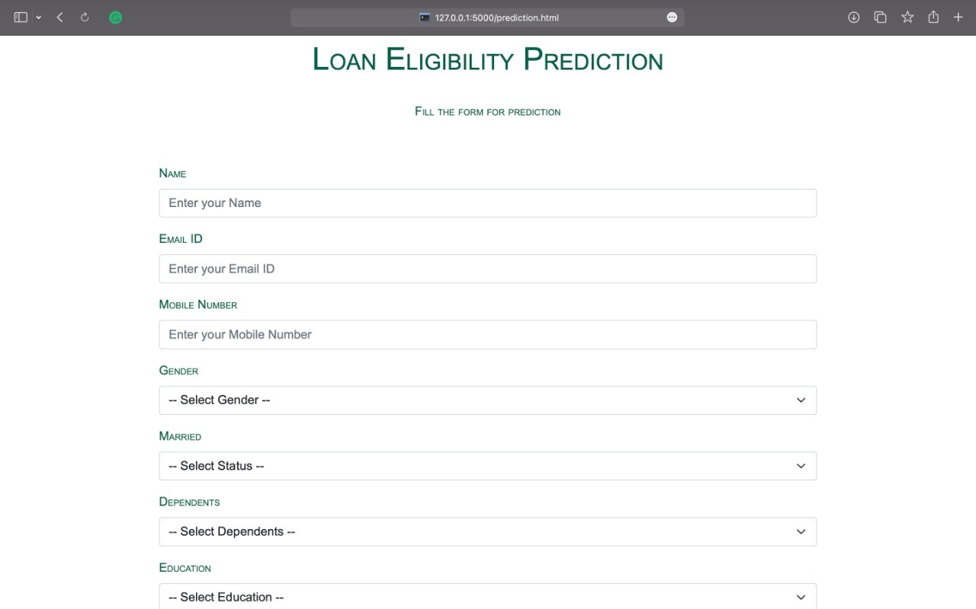

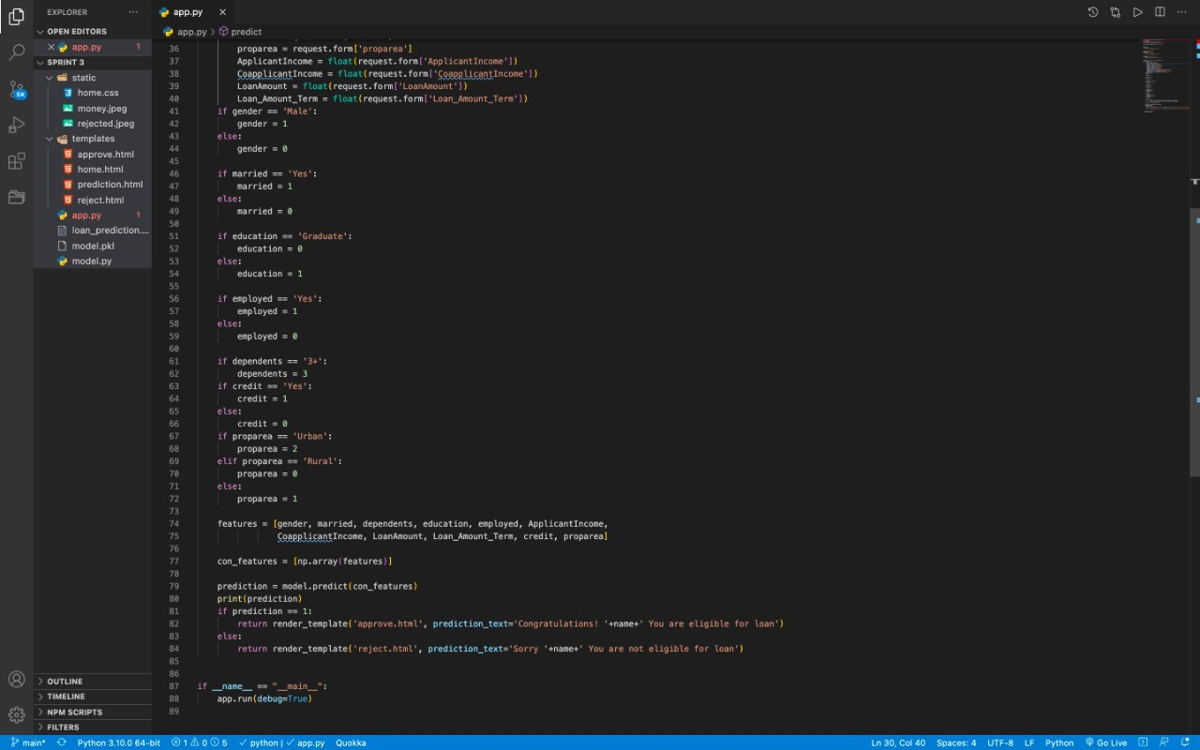
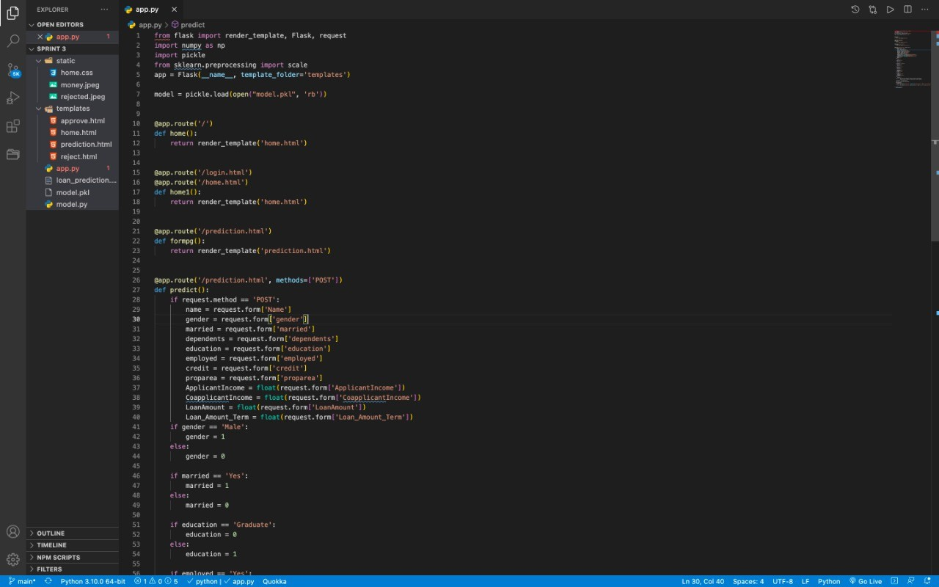

Feature 2
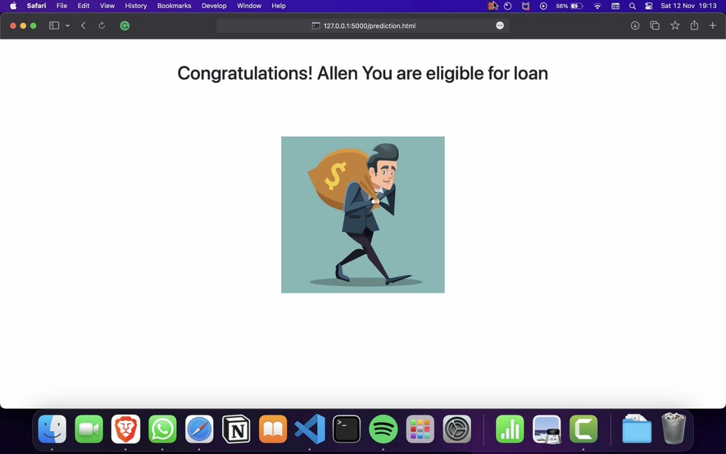

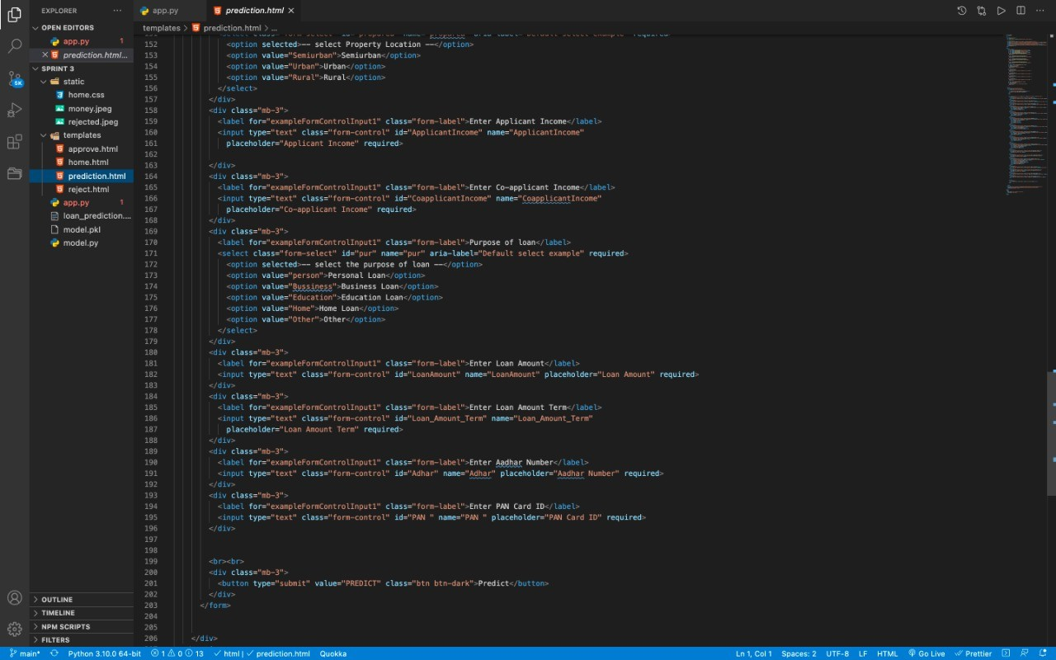

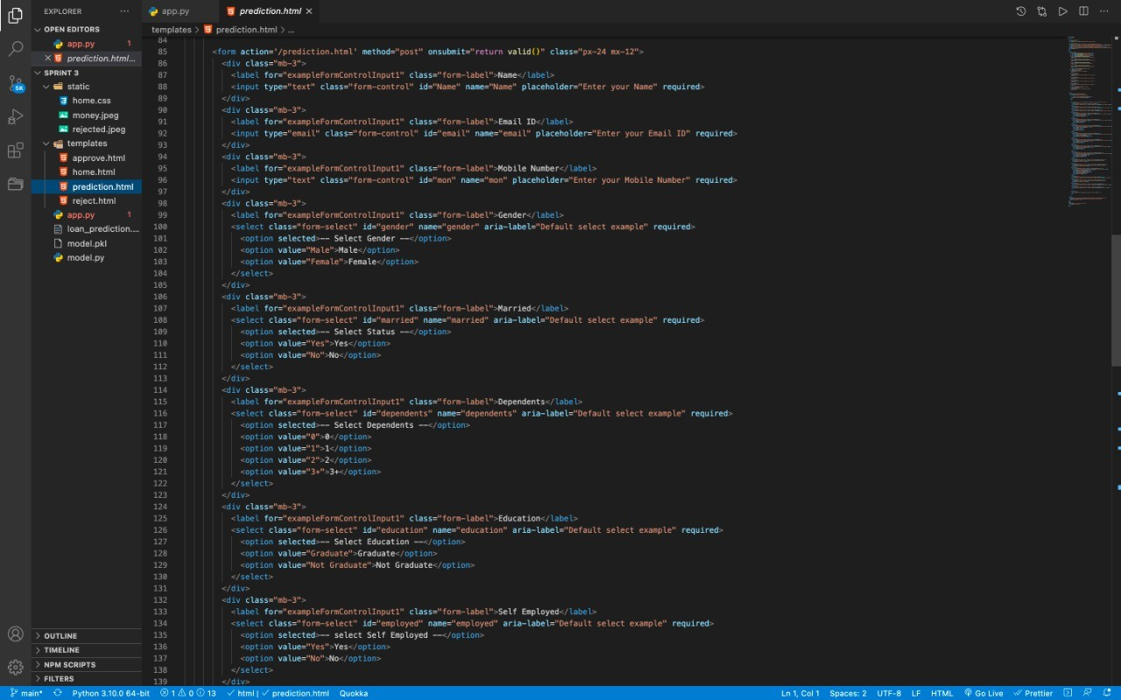

Chapter 7: TESTING

Test Cases

Test ca se  ID | Feature Type | Component | Test  Scenario | Pre-Requisite | Steps To Execute | Te st Da  ta | Expected Result | Actual Result | Stat us | Comments | TC for  Automation(Y/N) | BUG ID | Executed By
tc01 | Function al | e Page | Verify user is able to click on Predict  button |  | - Enter  URL and fill the form  - Click on Predict  button |  | Loan form should display | Working as expect ed | Pass
tc02 | Function al | Home Page | The web page is getting refresh  ed |  | - Automat ic page reload |  | Loan form must appear automatical ly after page  reload | Working as expect ed | Fail | No steps needed | Y | BUG-1234
tc03 | Function al | Home page | Field address validati  on |  | - Double-click on the E-mail  address  field |  | User should navigate to E-mail  address  field | Working as expect ed | Pass
tc04 | Function al | Output page | Loan Credibili  ty  predicted output |  | - Click on predict  button 2. View the predicted  results |  | User should access the Loan  credibility predicted  result | Working as expect ed | Pass

User Acceptance Testing
- Purpose of Document
The purpose of this document is to briefly explain the test coverage and open issues of the [ProductName] project at the time of the release to User Acceptance Testing (UAT).

Defect Analysis
This report shows the number of resolved or closed bugs at each severity level, and how they were resolved

Resolution | Severity 1 | Severity 2 | Severity 3 | Severity 4 | Subtotal
By Design | 9 | 3 | 1 | 2 | 15
Duplicate | 0 | 0 | 4 | 0 | 4
External | 1 | 2 | 0 | 0 | 3
Fixed | 10 | 5 | 4 | 21 | 40
Not Reproduced | 0 | 0 | 0 | 0 | 0
Skipped | 0 | 0 | 0 | 0 | 0
Won't Fix | 0 | 0 | 0 | 0 | 0
Totals | 20 | 9 | 9 | 23 | 6  4

Test Case Analysis
This report shows the number of test cases that have passed, failed, and untested

Section | Total Cases | Not Tested | Fa il | Pa ss
Print Engine | 5 | 0 | 0 | 5
Client Application | 46 | 0 | 0 | 46
Security | 4 | 0 | 0 | 4
Outsource Shipping | 3 | 0 | 0 | 3
Exception Reporting | 7 | 0 | 0 | 7
Final Report Output | 4 | 0 | 0 | 4
Version Control | 2 | 0 | 0 | 2

Chapter 8: RESULTS

8.1 Performance Metrics

Model Performance Testing:
Project team shall fill the following information in the model performance testing template.

S.No. | Parameter | Screenshot / Values
1 | Data Responsiveness | The ML model takes about 0.3 seconds to process the dataset. The credibility result is predicted in  approximately 0.9 seconds.
2 | Utilisation of Data Filters | Sufficient data filters have been used for ideal model building
3 | Effective User Story | No of Scene Added - 15
4 | Descriptive Reports | No of Visualisations / Graphs - 13

Chapter 9: ADVANTAGES & DISADVANTAGES

Advantages:
Keep Control of the Company
A bank loans money to a business based on the value of the business and its perceived ability to service the loan by making payments on time and in full. Unlike with equity finance where the business issues shares, banks do not take any ownership position in businesses. Bank personnel also do not get involved in any aspect of running a business to which a bank grants a loan. This means you ghet to retain full management and control of your business with no external interference.

Bank Loan is Temporary
Once a business borrower has paid off a loan, there is no more obligation to or involvement with the bank lender unless the borrower wishes to take out a subsequent loan. Compare this with equity finance, where the company may be paying out dividends to shareholders for as along as the business exists.

Interest is Tax Deductible
The interest on business bank loans is tax-deductible. In addition, especially with fixed-rate loans, in which the interest rate does not change during the course of a loan, loan servicing payments remain the same throughout the life of the loan. This makes it easy for businesses to budget and plan for monthly loan payments. Even if the loan is an adjustable-rate loan, business owners can use a simple spreadsheet to compute future payments in the event of a change in rates

Disadvantages:
Tough to Qualify
One of the greatest disadvantages to bank loans is that they are very difficult to obtain unless a small business has a substantial track record or valuable collateral such as real estate. Banks are careful to lend only to businesses that can clearly repay their loans, and they also make sure that

they are able to cover losses in the event of default. Business borrowers can be required to provide personal guarantees, which means the borrower's personal assets can be seized in the event the business fails and is unable to repay all or part of a loan.

High Interest Rates
Interest rates for small-business loans from banks can be quite high, and the amount of bank funding for which a business qualifies is often not sufficient to completely meet its needs. The high interest rate for the funding a business does receive often stunts its expansion, because the business needs to not only service the loan but also deal with additional funding to cover funds not provided by the bank. Loans guaranteed by the U.S. Small Business Administration offer better terms than other loans, but the requirements to qualify for these subsidized bank loans are very strict.

Chapter 10: CONCLUSION
The analysis starts from data cleaning and processing missing value, exploratory analysis and finally model building and evaluation of the model. The best accuracy on public test set is when we get higher accuracy score and other performance metrics which will be found out. This project can help to predict the approval of bank loan or not for a candidate.

Chapter 11: FUTURE SCOPE
In order to analyse the risk associated for the bank, credit evaluation largely involves gathering information about the customer and examining the project's technical, financial, and economic viability and this process developed a lot

Chapter 12: APPENDIX

Source Code index.html
<form action='/prediction.html' method="post" onsubmit="return valid()" class="px-24 mx-12">
<div class="mb-3">
<label for="exampleFormControlInput1" class="form-label">Name</label>
<input type="text" class="form-control" id="Name" name="Name" placeholder="Enter your Name" required>
</div>
<div class="mb-3">
<label for="exampleFormControlInput1" class="form-label">Email ID</label>
<input type="email" class="form-control" id="email" name="email" placeholder="Enter your Email ID" required>
</div>
<div class="mb-3">
<label for="exampleFormControlInput1" class="form-label">Mobile Number</label>
<input type="text" class="form-control" id="mon" name="mon" placeholder="Enter your Mobile Number" required>
</div>
<div class="mb-3">
<label for="exampleFormControlInput1" class="form-label">Gender</label>
<select class="form-select" id="gender" name="gender" aria-label="Default select example" required>
<option selected>-- Select Gender --</option>
<option value="Male">Male</option>
<option value="Female">Female</option>

</select>
</div>
<div class="mb-3">
<label for="exampleFormControlInput1" class="form-label">Married</label>
<select class="form-select" id="married" name="married" aria-label="Default select example" required>
<option selected>-- Select Status --</option>
<option value="Yes">Yes</option>
<option value="No">No</option>
</select>
</div>
<div class="mb-3">
<label for="exampleFormControlInput1" class="form-label">Dependents</label>
<select class="form-select" id="dependents" name="dependents" aria-label="Default select example" required>
<option selected>-- Select Dependents --</option>
<option value="0">0</option>
<option value="1">1</option>
<option value="2">2</option>
<option value="3+">3+</option>
</select>
</div>
<div class="mb-3">
<label for="exampleFormControlInput1" class="form-label">Education</label>
<select class="form-select" id="education" name="education" aria-label="Default select example" required>
<option selected>-- Select Education --</option>

<option value="Graduate">Graduate</option>
<option value="Not Graduate">Not Graduate</option>
</select>
</div>
<div class="mb-3">
<label for="exampleFormControlInput1" class="form-label">Self Employed</label>
<select class="form-select" id="employed" name="employed" aria-label="Default select example" required>
<option selected>-- select Self Employed --</option>
<option value="Yes">Yes</option>
<option value="No">No</option>
</select>
</div>
<div class="mb-3">
<label for="exampleFormControlInput1" class="form-label">Credit History</label>
<select class="form-select" id="credit" name="credit" aria-label="Default select example" required>
<option selected>-- select Credit History --</option>
<option value="Yes">Yes</option>
<option value="No">No</option>

</select>
</div>
<div class="mb-3">
<label for="exampleFormControlInput1" class="form-label">Property Location</label>
<select class="form-select" id="proparea" name="proparea" aria-label="Default select example" required>

<option selected>-- select Property Location --</option>
<option value="Semiurban">Semiurban</option>
<option value="Urban">Urban</option>
<option value="Rural">Rural</option>
</select>
</div>
<div class="mb-3">
<label for="exampleFormControlInput1" class="form-label">Enter Applicant Income</label>
<input type="text" class="form-control" id="ApplicantIncome" name="ApplicantIncome" placeholder="Applicant Income" required>

</div>
<div class="mb-3">
<label for="exampleFormControlInput1" class="form-label">Enter Co-applicant Income</label>
<input type="text" class="form-control" id="CoapplicantIncome" name="CoapplicantIncome" placeholder="Co-applicant Income" required>
</div>
<div class="mb-3">
<label for="exampleFormControlInput1" class="form-label">Purpose of loan</label>
<select class="form-select" id="pur" name="pur" aria-label="Default select example" required>
<option selected>-- select the purpose of loan --</option>
<option value="person">Personal Loan</option>
<option value="Bussiness">Business Loan</option>
<option value="Education">Education Loan</option>
<option value="Home">Home Loan</option>

<option value="Other">Other</option>
</select>
</div>
<div class="mb-3">
<label for="exampleFormControlInput1" class="form-label">Enter Loan Amount</label>
<input type="text" class="form-control" id="LoanAmount" name="LoanAmount" placeholder="Loan Amount" required>
</div>
<div class="mb-3">
<label for="exampleFormControlInput1" class="form-label">Enter Loan Amount Term</label>
<input type="text" class="form-control" id="Loan_Amount_Term" name="Loan_Amount_Term"
placeholder="Loan Amount Term" required>
</div>
<div class="mb-3">
<label for="exampleFormControlInput1" class="form-label">Enter Aadhar Number</label>
<input type="text" class="form-control" id="Adhar" name="Adhar" placeholder="Aadhar Number" required>
</div>
<div class="mb-3">
<label for="exampleFormControlInput1" class="form-label">Enter PAN Card ID</label>
<input type="text" class="form-control" id="PAN " name="PAN " placeholder="PAN Card ID" required>
</div>

<br><br>
<div class="mb-3">
<button type="submit" value="PREDICT" class="btn btn-dark">Predict</button>
</div>
</form>

app.py

from ﬂask import render_template, Flask, request import numpy as np
import pickle
from sklearn.preprocessing import scale
app = Flask(_name_, template_folder='templates')

model = pickle.load(open("model.pkl", 'rb'))

@app.route('/') def home():
return render_template('home.html')

@app.route('/login.html') @app.route('/home.html') def home1():
return render_template('home.html')

@app.route('/prediction.html') def formpg():
return render_template('prediction.html')

@app.route('/prediction.html', methods=['POST']) def predict():
if request.method == 'POST': name = request.form['Name'] gender = request.form['gender']
married = request.form['married'] dependents = request.form['dependents'] education = request.form['education'] employed = request.form['employed'] credit = request.form['credit']
proparea = request.form['proparea']
ApplicantIncome = ﬂoat(request.form['ApplicantIncome']) CoapplicantIncome = ﬂoat(request.form['CoapplicantIncome']) LoanAmount = ﬂoat(request.form['LoanAmount']) Loan_Amount_Term = ﬂoat(request.form['Loan_Amount_Term'])
if gender == 'Male': gender = 1
else:
gender = 0

if married == 'Yes': married = 1
else:
married = 0

if education == 'Graduate': education = 0

else:
education = 1

if employed == 'Yes': employed = 1
else:
employed = 0

if dependents == '3+': dependents = 3
if credit == 'Yes': credit = 1
else:
credit = 0
if proparea == 'Urban': proparea = 2
elif proparea == 'Rural': proparea = 0
else:
proparea = 1

features = [gender, married, dependents, education, employed, ApplicantIncome, CoapplicantIncome, LoanAmount, Loan_Amount_Term, credit, proparea]

con_features = [np.array(features)]

prediction = model.predict(con_features) print(prediction)

if prediction == 1:
return render_template('approve.html', prediction_text='Congratulations! '+name+' You are eligible for loan')
else:
return render_template('reject.html', prediction_text='Sorry '+name+' You are not eligible for loan')

if _name_ == "_main_": app.run(debug=True)

